
Netflix Content Strategy Dashboard
Project Overview
This project delivers a strategic, leadership-oriented analysis of Netflix’s content portfolio using data analytics and interactive visualization.
Rather than focusing only on descriptive statistics, the project is designed to uncover how Netflix’s content choices translate into scale, engagement, and long-term strategic advantage. The dashboard enables senior stakeholders to explore trade-offs between content volume, retention drivers, audience maturity, and refresh dependency through interactive KPIs and slicers.
The final output is a Power BI executive dashboard, supported by Python-based exploratory data analysis and AI-assisted insights.
Objectives
- Understand Netflix’s content scale and composition
- Identify retention anchors vs scale drivers
- Analyse audience maturity concentration
- Translate KPIs into actionable leadership insights
- Build an interactive, decision-support dashboard
Tools Used
🔹 Julius AI
- Used for AI-assisted exploratory data analysis
- Helped accelerate hypothesis generation and pattern identification
- Supported early analytical direction
🔹 Python (Pandas)
- Used for data loading, cleaning, and exploratory analysis
- Generated analytical summaries used in dashboard design
- Handled multi-value fields (countries, genres, durations)
🔹 Power BI
- Used to build the interactive executive dashboard
- Implemented slicer-driven KPIs and strategic visuals
- Designed with leadership decision-making in mind
🔹 ChatGPT
- Used as a strategic co-pilot
- Assisted in:
- Structuring the analytical narrative
- Designing KPI logic
- Translating analysis into leadership-grade insights
- Framing the dashboard story and README documentation
Data Preparation & Exploratory Analysis (Python)
1️⃣ Initial Data Loading & Inspection
Purpose:
Load the Netflix dataset and understand its structure, schema, and missing values.
Key actions:
- Read CSV data
- Inspect schema and data types
- Identify missing values
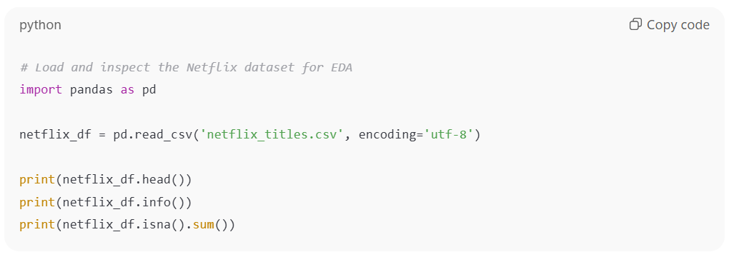
2️⃣ Exploratory Data Analysis (EDA)
Purpose:
Generate foundational insights on content distribution, trends, genres, ratings, and durations.
Analyses performed:
- Movie vs TV Show distribution
- Year-wise content addition trends
- Country-wise content contribution (handling multi-country entries)
- Genre popularity analysis
- Rating distribution across content types
- Duration analysis for Movies and TV Shows
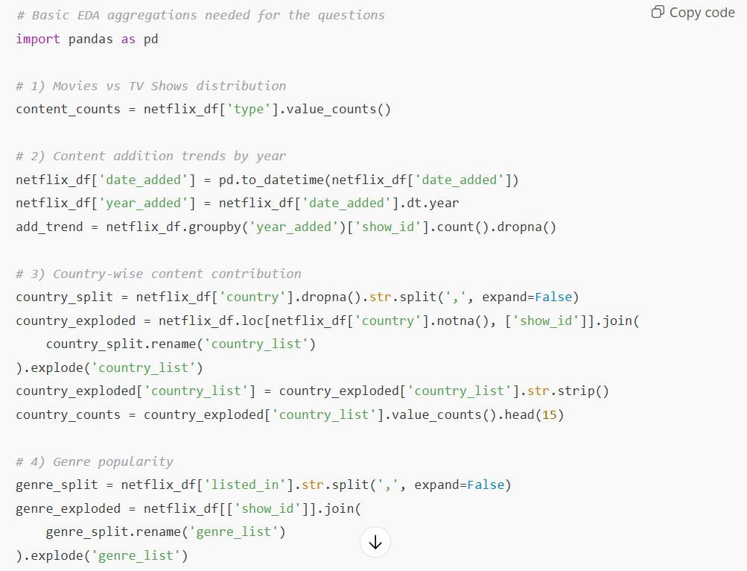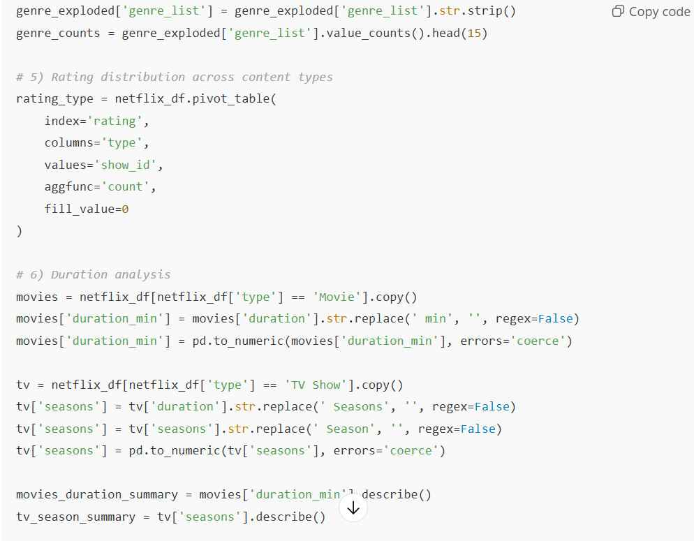
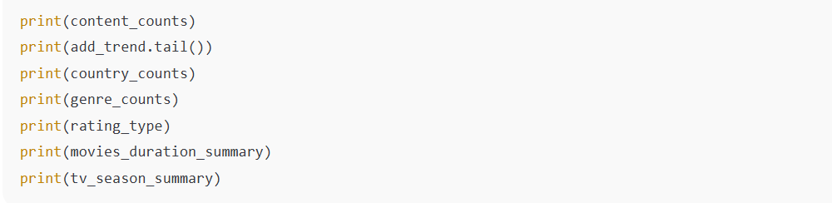
3️⃣ Robust Date Handling & Trend Validation
Purpose:
Ensure reliability when parsing inconsistent date formats
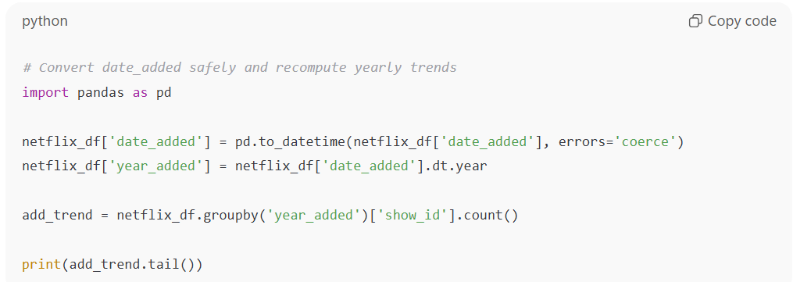

Power BI Dashboard
Dashboard Structure
- Page 0 – Executive Overview
  - Global slicers (Content Type, Genre, Country, Rating)
  - KPI cards for scale, retention, maturity, and refresh pressure
  - Designed as a control tower for leadership
- Page 1 & 2 – Analytical Deep-Dives
  - Genre × Content Type analysis
  - Audience maturity and engagement patterns
  - Visual storytelling for retention logic
- Final Page – Strategic Insight
  - KPI-driven leadership signals
  - Visual-first, action-oriented insights
  - Focus on trade-offs between scale, engagement, and sustainability
How to Run the Project
  - Python Analysis
  - Ensure netflix_titles.csv is available
  - Run the Python scripts for data inspection and EDA
  - Power BI Dashboard
  - Open Final Data Final Data Assignment.pbix
  - Use Page 0 slicers to control the entire dashboard
  - Navigate through analytical and insight pages
Key Takeaway
  - This project transforms raw Netflix content data into a decision-support system, enabling leadership to understand where content investment creates the most strategic leverage.
  - Netflix’s advantage is not driven by content volume alone, but by how precisely content investment is allocated between scale, engagement, and longevity.

